Welcome to the AWS Gen AI Hackathon!

The first step in creating a prize wining hackathon entry is to log into your account and setup a MFA Authenticator for your account

Each team will have their own AWS Account to create your Gen AI Hackathon entry.
We have tried to set you up from the start with enough permissions to accomplish what you need to do. Please email us at awshackathonhelp.us@capgemini.com if you have any questions.

You will access your AWS Hackathon environment through this URL: https://d-9067d32c4c.awsapps.com/start
Please read the entire document before attempting to login.

Rules and Limitations for using your Hackathon account
There will be certain rules and limitations for your Hackathon account to maintain good security and prevent abuse. The main limits to be aware of are:

Unable to create users
You will not be allowed to create additional logins.

Limits to LLMs allowed
You may use only Amazon Titan models.

Limits to S3 features
You may not make S3 buckets public or remove encryption.

You can only use the us-east-1 Region
You must create all Hackathon resources in the North Virgina (us-east-1) region.
The AWS Console will be allow you to switch to other regions but any attempts to create any AWS resources in other Regions will fail.

If you are trying to do a function that you think should be allowed, first check your region to ensure you are in the North Virginia us-east-1 region.
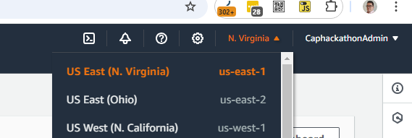

You cannot make VPC changes
VPC changes are not allowed.

Limits of ECS and RDS instances
You can create t3.medium and m5.large instances
RDS is limited at this time.

Getting access to your Hackathon environment
You should get an email invitation from AWS on how to access your Hackathon environment. There will be instructions below (the “If you didn’t get an ‘Invitation to join AWS IAM Identity Center’ email” section).

We are using IAM Identity Center (“IDC”) to enable your access. We will require Multifactor Authentication (MFA) for your login to maintain security.

Follow the steps below to complete your IDC setup and establish your MFA validation for the account.

Accepting your invitation to access your Hackathon environment
You will get an email in your Capgemini Outlook with the subject line “Invitation to join AWS IAM Identity Center”.

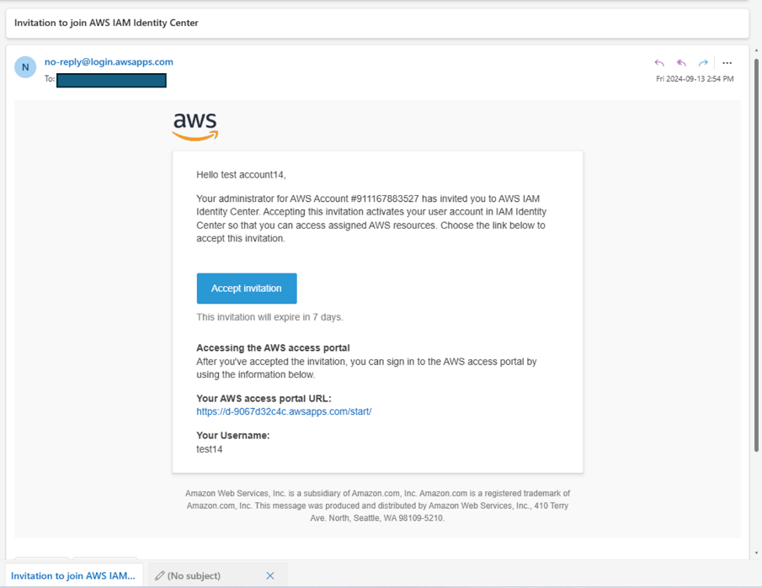

Make note of the AWS access Portal URL; this will be where you login.
Hackathon Portal Access: https://d-9067d32c4c.awsapps.com/start

Click the Accept Invitation Button in the email.

Enter a Password in the New user sign up dialog and click the Set new password button.
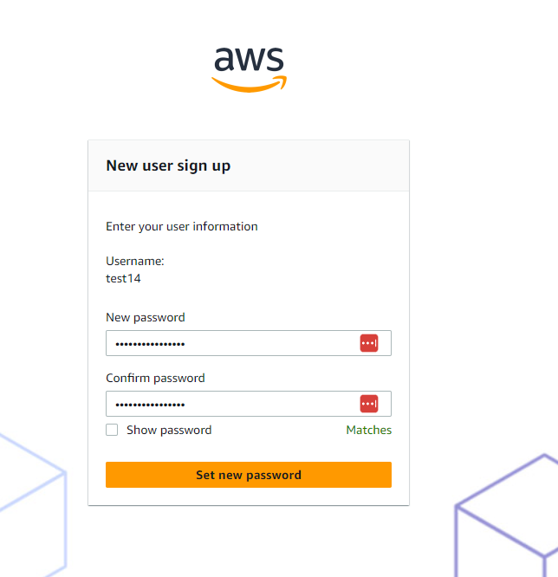

A dialog box will show a “Successfully created” message before redirecting you to the login and MFA setup.
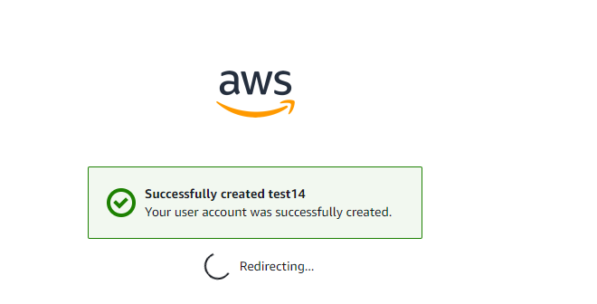

If you didn’t get an ‘Invitation to join AWS IAM Identity Center’ email
There may be several reasons why the “Invitation to join AWS IAM Identity Center” email didn’t make it to you Capgemini Outlook inbox; we have a workaround!

- Go to the AWS Hackathon Login portal: https://d-9067d32c4c.awsapps.com/start
- Enter your Capgemini email in the Username field and click the Next button.
- In the Sign in dialog box, click the Forgot password link.
- Complete the CAPTCHA and click the Next button.
- Click the Reset Password button in the email.
- Enter your New password (and make it a good password!) and click the Set new password button.
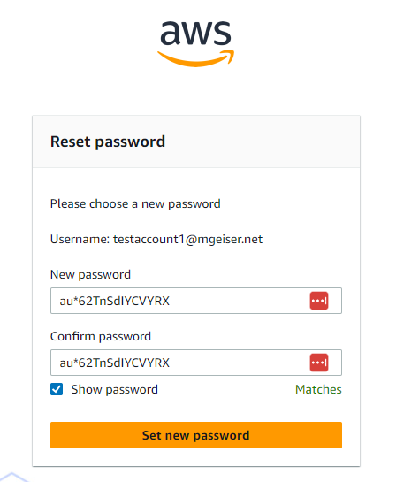 | (and you are correct that that is not the password for testaccount1…)

- Continue to the Login and MFA setup section.

Login and MFA setup
The link will take you to the initial sign-in page and should auto-populate your Capgemini email.

Click the Next button to continue with the login.

Enter your password and click the Sign in button.
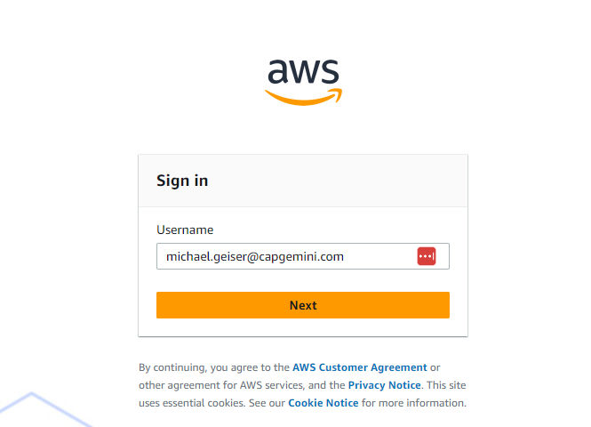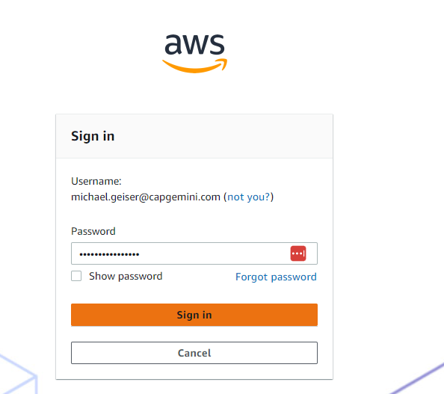

Set up MFA
You will have to Register and use a multi-factor authentication login for logging into your Hackathon environment. We will show this process using the Microsoft Authenticator App.

Select the radio button for the “Authenticator App” and click the Next button.

Follow the directions to:
Scan the QR code to add the user to your Authenticator App
Enter the Authenticator Code from your MFA application into the box in section 3
Click the Assign MFA button.

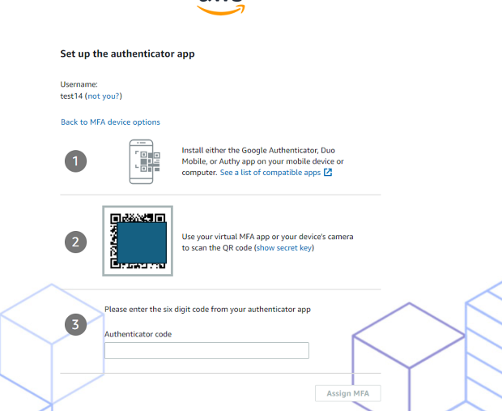

Success!
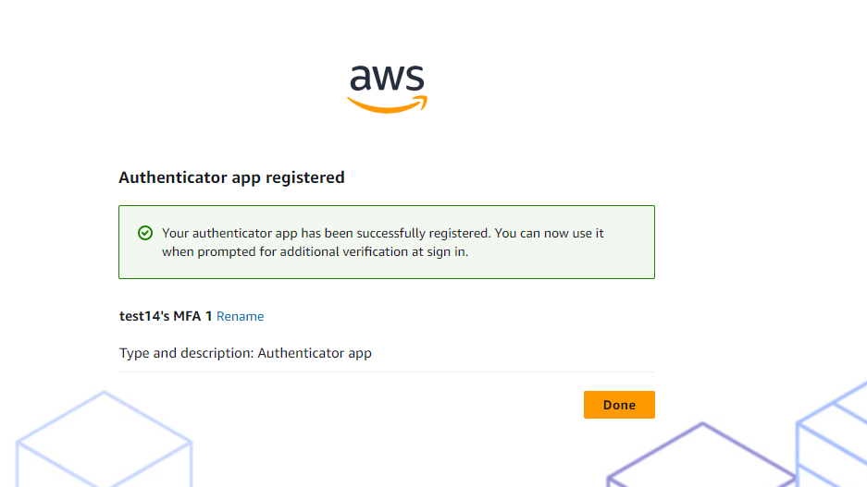

Click the Done button.

Login to your AWS Hackathon Account

Enter your Username and click the Next button. | Enter your password, select the This is a trusted device checkbox and click the Sign in button. | Enter the current MFA code and click the Sign in button.
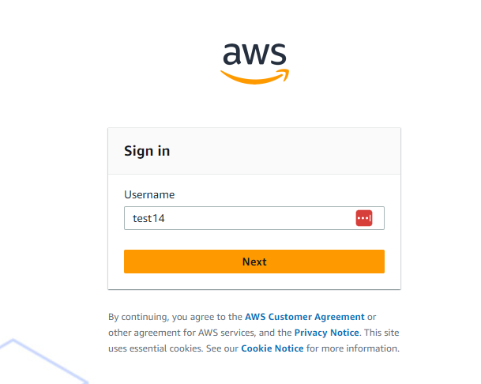  hackathon.user@capgemini.com | 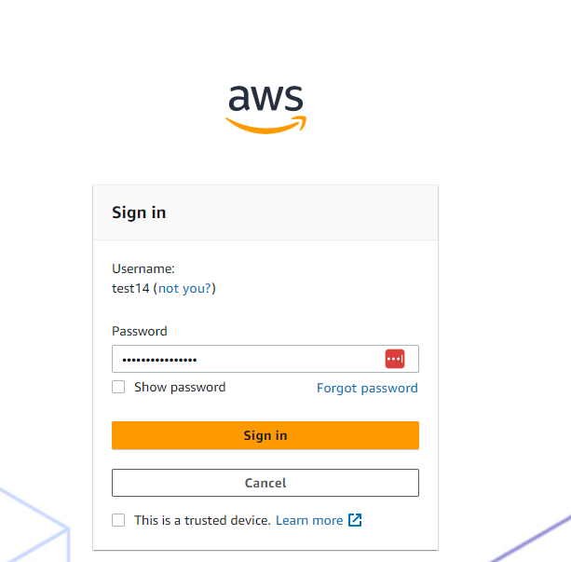 | 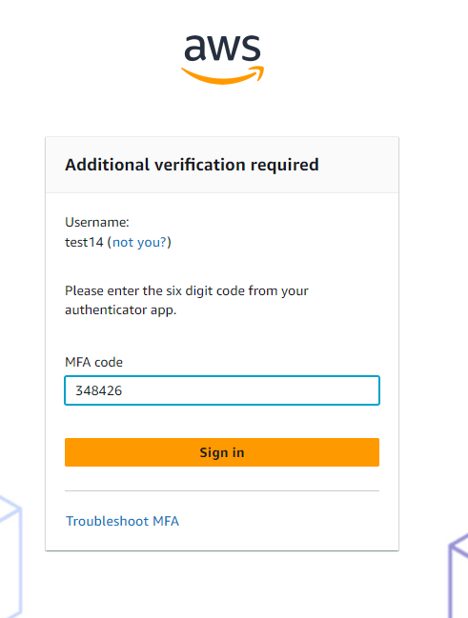

The AWS Access Portal and accessing your Hackathon account

After successfully logging in, you should have one AWS Account listed in the AWS Access Portal.
The name, number and email address for “ParticipantAccount2” below are identifiers only.

To access your account, you need to click on the “caret” (the small triangle) so it opens.
If you hover your mouse over the “ParticipantPermissionSet” text, you will see it is a link.

Click the link.
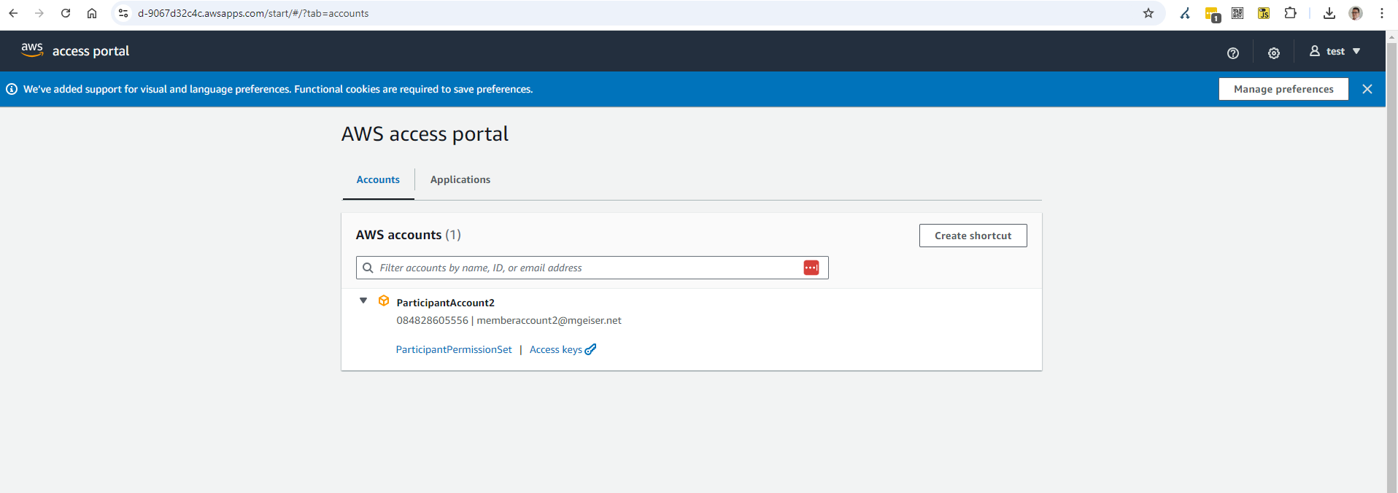

Your AWS Hackathon environment will open.
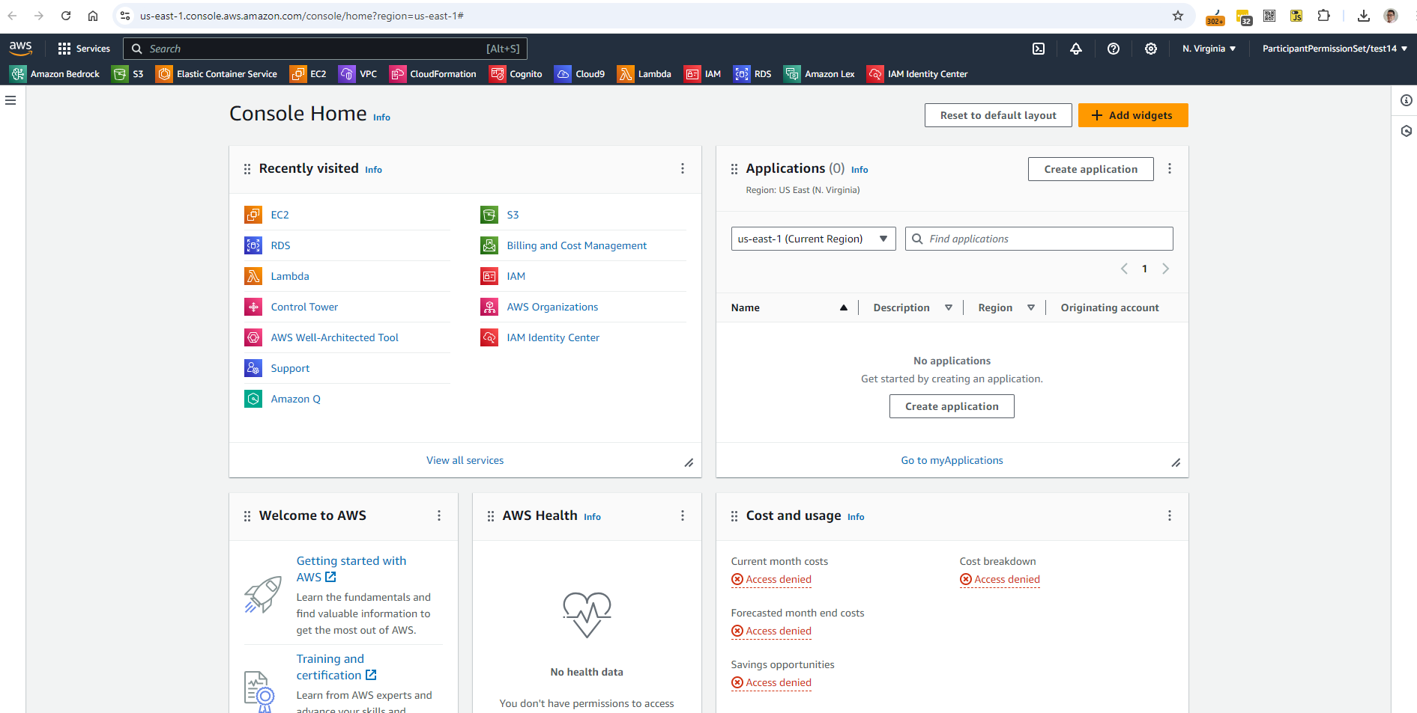

Start your Hackathon Journey!
Go ahead and start creating the next great prize-winning Gen AI app!

